Changes which need to be made in the report-
For comment 1:
This sentence is commented- 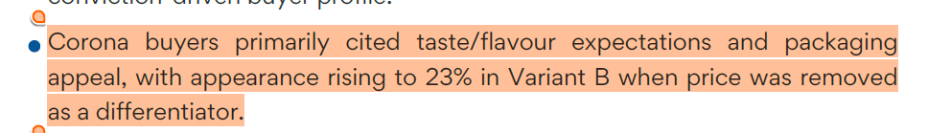
The number 23% is incorrect, a better sentence which calculates a greater meaning is Suggested wording:
"Appearance as the top factor rose from 6.8% to 17.9% in Variant B.
Brand trust (40.3%) was the leading motivator among Corona buyers."
Or
We can simply replace 23% with 17.9% in the highlighted statement
For comment 2:
This sentence has been commented-
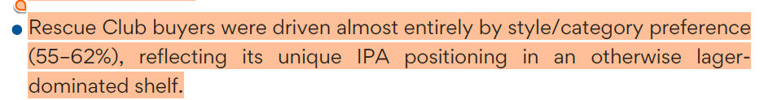
This Statement needs to be replaced with:
Suggested wording:
"Rescue Club buyers were primarily motivated by IPA/style preference
(~55% in A, ~57-62% in B), though packaging was also important for
about one-third of Variant B buyers."
For Comment 3:
In this page:
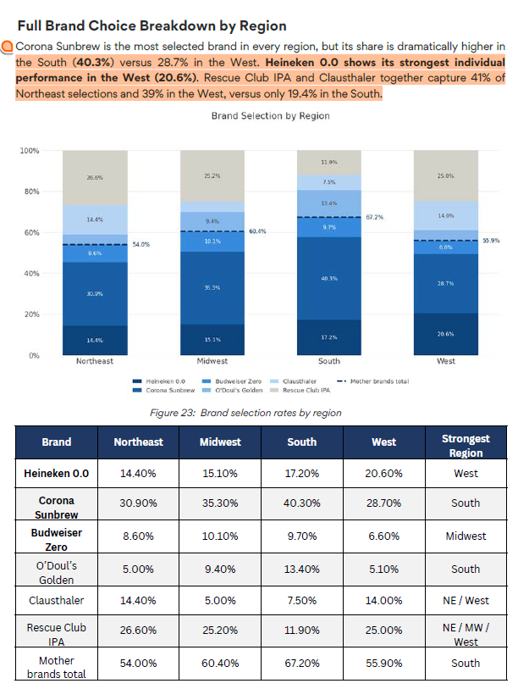
There is no need to change the highlighted statement, however we need to change the plot/chart and the table.
The updated chart is :
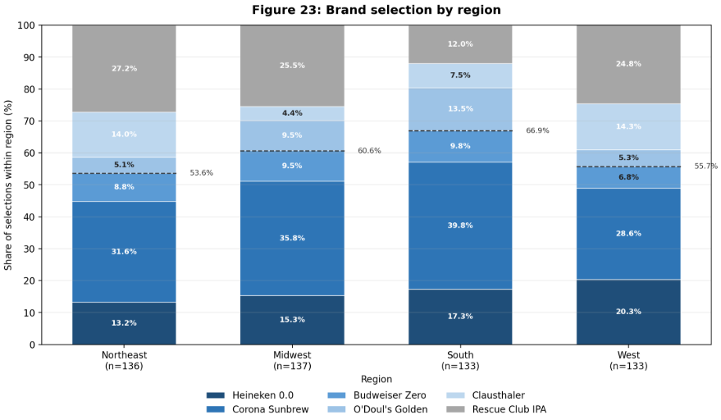
Updated Table-
brand | Northeast | Midwest | South | West | Strongest region
Heineken 0.0 | 13.2 | 15.3 | 17.3 | 20.3 | West
Corona Sunbrew | 31.6 | 35.8 | 39.8 | 28.6 | South
Budweiser Zero | 8.8 | 9.5 | 9.8 | 6.8 | South
O'Doul's Golden | 5.1 | 9.5 | 13.5 | 5.3 | South
Clausthaler | 14 | 4.4 | 7.5 | 14.3 | West
Rescue Club IPA | 27.2 | 25.5 | 12 | 24.8 | Northeast
Mother brands total | 53.6 | 60.6 | 66.9 | 55.7 | South

Comment 4:
Update these two graphs with-
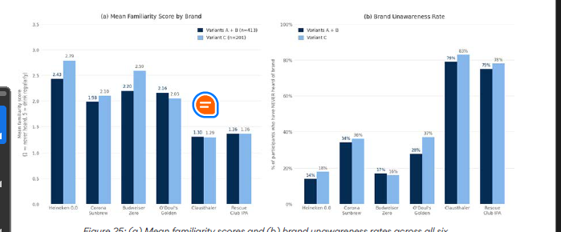
With these two graphs-
